

AI Job Matching System
(نظام المطابقة الذكية للوظائف باستخدام الذكاء الاصطناعي)

Under the Supervision of:
Dr. Mona Arafa
Eng. Fatma Ragab

Prepared by

السكشن | الاسم
19 | (Team Leader)  محمد تامر محمد على الشيخ
19 | محمد خالد عبد الله الطيب محمود محمد البعلى
19 | محمد رضا إبراهيم إبراهيم مصطفى
19 | محمد رأفت حسن تهامى حسن
19 | محمد داود محمد المشوخى
19 | محمد حامد عبد السميع السيد محمد

Table of Contents
Section 1. Project Overview 3
1.1 Project Description 3
1.2 Project Scope 3
1.3 Assumptions 4
1.4 Constraints 5

Section 2. Project Start-Up 6
2.1 Project Life Cycle 6
2.2 Methods, Tools, and Techniques 6
2.3 Estimation Methods and Estimates 8
2.4 Schedule Allocation 9
2.5 Resource Allocation 10
2.6 Budget Allocation 11

Section 3. Risk Management 12

Section 4. Project Scheduling & Feasibility (Appendices) 13
4.1 PERT Analysis 14
4.2 Network Diagram and Critical Path Description 15
4.3 Gantt Chart Description 17
4.4 Economic Feasibility Analysis 18

Click Here To Check The Full Project Repository On GitHub

Section 1. Project Overview

1.1 Project Description
The AI Job Matching System is a cutting-edge, intelligent recruitment platform designed to bridge the gap between job seekers and employers through the power of Artificial Intelligence and Machine Learning. The system collects and processes candidate resumes, employer job postings, and user behavioral data to generate highly accurate compatibility scores that automate and optimize the talent acquisition process. By leveraging Natural Language Processing (NLP), collaborative filtering, and deep learning models, the platform moves beyond simple keyword matching toward contextual, semantic understanding of candidate qualifications and employer requirements.

Project Objectives:
- Develop a robust, scalable AI-powered recruitment platform capable of processing thousands of resumes and job listings simultaneously.
- Implement advanced NLP and ML algorithms to generate precise candidate-to-job compatibility scores.
- Design intuitive dashboards for both job seekers and employers with real-time notifications and recommendations.
- Ensure data privacy, algorithmic fairness, and compliance with applicable labor laws and GDPR-equivalent regulations.
- Provide comprehensive API integrations with LinkedIn, Indeed, and other third-party job boards.
- Deliver full documentation, training resources, and post-deployment support for all system stakeholders.

1.2 Project Scope
The project encompasses the end-to-end design, development, testing, and deployment of an AI-powered job matching platform. The scope covers resume ingestion and parsing, AI-driven matching engine, employer and candidate portals, notification services, and reporting dashboards.

Project Includes
# | Feature / Component | Description
1 | Resume Parsing & Ingestion | Automated extraction of structured data (skills, experience, education) from uploaded PDF/DOCX resumes using NLP.
2 | AI Matching Algorithm | ML model that computes candidate-job compatibility scores using semantic similarity and collaborative filtering.
3 | Job Seeker Dashboard | Personalized portal showing job recommendations, application status, and profile management.
4 | Employer Dashboard | Interface for posting vacancies, reviewing ranked candidates, and scheduling interviews.
5 | Notification & Alerting Service | Real-time email and in-app notifications for match events, application updates, and interview reminders.
6 | Admin Control Panel | Backend management for users, system configuration, AI model retraining, and audit logs.
7 | Third-Party API Integration | Integration with LinkedIn, Indeed, Google Jobs, and SMTP providers.
8 | Analytics & Reporting | Dashboards for hiring metrics, match accuracy, user engagement, and system performance KPIs.
9 | Authentication & Authorization | Secure role-based access control (RBAC) with JWT and OAuth 2.0 support.
10 | Search & Filter Engine | Advanced search with Boolean filters, location radius, salary range, and skill tags.

Project Excludes
# | Excluded Feature | Reason
1 | Payroll Management System | Out of scope; requires separate HR financial integration not relevant to matching.
2 | Video Interviewing Platform | Third-party tools (Zoom, MS Teams) cover this; building it in-house is outside scope.
3 | Background Check Services | Managed by external vendors; only API integration link is referenced.
4 | Learning Management System (LMS) | Candidate upskilling platform is a separate project initiative.
5 | Hardware / Infrastructure Procurement | Cloud-based deployment on AWS; no hardware development required.
6 | Mobile Native App (iOS/Android) | Phase 2 deliverable; only responsive web app is in scope for Phase 1.
7 | Proprietary Job Board Data Licensing | External licensing negotiated separately by procurement team.

1.3 Assumptions
- Data Availability: The project assumes that sufficient anonymized resume datasets and job posting data will be available for AI model training and validation during the development phase.
- Infrastructure Access: It is assumed that cloud infrastructure (AWS EC2, S3, RDS) will be provisioned and accessible within the first two weeks of the project.
- Stakeholder Availability: Key stakeholders (HR managers, IT leads, and legal counsel) are assumed to be available for requirements workshops and review sessions.
- Regulatory Compliance: The project assumes legal team will provide timely guidance on data privacy requirements, enabling compliance features to be implemented correctly.
- API Access: Third-party platforms (LinkedIn, Indeed) will grant API access under standard developer agreements with no significant delays.
- Team Expertise: The development team is assumed to possess working knowledge of Python, React, cloud deployment, and basic ML frameworks such as scikit-learn and Hugging Face Transformers.
- Budget Stability: The allocated budget will remain stable and not subject to mid-project cuts or scope change reductions.

1.4 Constraints
Technological Constraints:
- Compatibility with existing enterprise HR systems (e.g., SAP SuccessFactors) may impose integration constraints.
- AI model performance is bounded by the quality and quantity of training data available.
- Real-time matching at scale requires high-performance computing resources, which may exceed budget.
Budget Constraints:
- Total project budget is capped at $175,000, limiting the selection of premium third-party APIs.
- Budget constraints may require deferral of mobile application development to a subsequent phase.
Time Constraints:
- The project must be completed within 5 calendar months to align with the Q3 company hiring cycle.
- Regulatory review cycles may cause delays in feature deployment if not planned in advance.
Regulatory Constraints:
- Compliance with GDPR, Egypt's Personal Data Protection Law (Law No. 151/2020), and applicable employment laws is mandatory.
- AI fairness and anti-discrimination standards must be adhered to, limiting certain types of automated decision-making.
Resource Constraints:
- Limited availability of senior ML engineers may require augmenting the team with contractors.
- Access to labeled training data for resume parsing models may be limited by NDA restrictions.
Stakeholder Expectations:
- HR stakeholders expect an easy-to-use UI with minimal training required, constraining UI complexity.
- Employers demand candidate ranking accuracy above 85%, creating a strict ML performance benchmark.
Scope Constraints:
- The initial release will support Arabic and English only; additional languages are excluded from scope.
- The system will handle up to 50,000 active user profiles at launch; higher scalability is Phase 2.
External Dependencies:
- Dependency on LinkedIn/Indeed API rate limits may constrain data ingestion frequency.
- Third-party email/SMS notification service availability will directly impact alerting reliability.

Section 2. Project Start-Up

2.1 Project Life Cycle
Phase | Activities | Sequence
Planning | • Define project charter • Establish project initiation team • Build relationship with client stakeholders • Set up project management environment • Define project workbook & communication plan | Phase 1
Analysis | • Conduct preliminary investigation • Survey current recruitment processes • Gather functional & non-functional requirements • Conduct stakeholder interviews • Produce system analysis report | Phase 2
Design | • Design system architecture (microservices on AWS) • Define data models (ERD, relational schema) • Design AI/ML pipeline & matching algorithm • Create UI/UX wireframes and prototypes • Define API contracts (REST/OpenAPI) | Phase 3
Implementation (Coding & Testing) | • Develop backend services (Python/FastAPI) • Build React frontend dashboards • Implement NLP resume parser • Train and validate ML matching model • Perform unit, integration & UAT testing • Resolve defects and performance issues | Phase 4
Deployment & Closure | • Deploy to AWS production environment • Configure CI/CD pipelines • Train end users and administrators • Hand over documentation • Conduct post-launch monitoring | Phase 5

2.2 Methods, Tools, and Techniques
1. Development Methodologies
- Agile (Scrum): Two-week sprints with daily stand-ups, sprint reviews, and retrospectives to accommodate evolving AI model requirements.
- DevOps Practices: Continuous integration and deployment with automated pipelines to ensure reliable, fast delivery cycles.
- Test-Driven Development (TDD): Writing unit tests before implementation to guarantee code correctness, especially for the matching algorithm.
2. Standards and Policies
- ISO 9001: Quality management standard applied to project documentation and deliverable review processes.
- GDPR & Egyptian Data Protection Law: All data handling, storage, and processing must comply with relevant privacy regulations.
- AI Ethics Standards: IEEE Ethically Aligned Design and EU AI Act guidelines applied to ensure fairness and transparency in algorithmic matching.
- REST API Standards (OpenAPI 3.0): All external and internal APIs documented and versioned according to OpenAPI specification.
3. Procedures
- Development Procedures: Standardized coding conventions (PEP8 for Python, ESLint for JavaScript), mandatory code reviews via pull requests.
- Deployment Procedures: Blue-green deployment strategy on AWS to ensure zero-downtime production releases.
- Model Retraining Procedures: Scheduled monthly retraining of the matching model using updated resume/job data with automated A/B evaluation.
4. Programming Languages
- Python 3.11: Core language for AI/ML pipeline, NLP resume parsing, and backend API services.
- JavaScript / TypeScript (React 18): Frontend dashboards for job seekers, employers, and administrators.
- SQL (PostgreSQL): Structured data storage for users, job postings, resumes, and match results.
- HTML5 & CSS3 (Tailwind CSS): Markup and styling for responsive web interface.
5. Reusable Code Repositories
- GitHub: Primary version control platform for code hosting, branch management, and pull request workflows.
- GitLab CI/CD: Automated pipeline execution for testing, building, and deploying the application.
- PyPI / npm Registry: Package hosting for internal shared libraries and frontend component libraries.
6. Notations
- Unified Modeling Language (UML): Use case diagrams, class diagrams, sequence diagrams, and activity diagrams for system modeling.
- Data Flow Diagrams (DFD): Context diagram, Level 0, and Level 1 DFDs to model data movement across the system.
- Entity-Relationship Diagrams (ERD): Database schema design for all core entities and their relationships.
7. Tools
- IDEs: VS Code, PyCharm Professional, and Jupyter Notebooks for development and ML experimentation.
- DBMS: PostgreSQL 15 for relational data; Redis for caching job recommendations and session data.
- ML Frameworks: scikit-learn, Hugging Face Transformers (BERT), spaCy for NLP and model training.
- Cloud Platform: AWS (EC2, S3, RDS, Lambda, SageMaker) for infrastructure, storage, and model hosting.
- Project Management: Jira for sprint tracking, Confluence for documentation, Slack for team communication.
- UI/UX Design: Figma for wireframes and interactive prototypes reviewed by stakeholders.

8. Techniques
- CI/CD Pipelines: GitHub Actions and AWS CodePipeline automate testing and deployment on every code merge.
- Natural Language Processing (NLP): Tokenization, named entity recognition, and semantic embeddings for resume and job description analysis.
- Collaborative Filtering & Cosine Similarity: Core techniques for generating candidate-job match scores.
- Containerization (Docker & Kubernetes): Microservices packaged in Docker containers, orchestrated by Kubernetes on AWS EKS.
- Data Mining & Feature Engineering: Extraction of key candidate signals (years of experience, skill taxonomy mapping, career trajectory).

2.3 Estimation Methods and Estimates
The estimation for the AI Job Matching System is derived from a combination of expert judgment, bottom-up estimation, and historical data benchmarking from comparable AI recruitment platform projects. Three-point PERT estimation (Best, Most Likely, Worst) is applied to account for the inherent uncertainty in AI model development cycles.

Parameter | Best Estimate | Most Likely Estimate | Worst Estimate
Effort (person-hours) | 2,400 person-hours | 3,200 person-hours | 4,000 person-hours
Schedule  (calendar months) | 3 months | 4 months | 5 months
Budget (USD) | $130,000 | $155,000 | $175,000
Level of Uncertainty (%) | 15% | 25% | 40%

2.4 Schedule Allocation
# | Major Milestone / Deliverable | Effort (Days)
1 | Establishing the project initiation team | 3 days
2 | Establishing a relationship with the client | 5 days
3 | Establishing the project initiation team plan | 2 days
4 | Setting up the project management environment and workbook | 2 days
5 | Preliminary investigation and feasibility study | 4 days
6 | System survey and study of current recruitment processes | 7 days
7 | Determination of user requirements (workshops & interviews) | 5 days
8 | Systems analysis report and requirements specification | 4 days
9 | AI/ML pipeline design and matching algorithm architecture | 5 days
10 | Database design (ERD, relational schema, data dictionary) | 3 days
11 | UI/UX wireframes and prototype design | 7 days
12 | Backend development (APIs, authentication, resume parser) | 20 days
13 | AI matching model training, evaluation, and optimization | 15 days
14 | Frontend development (dashboards and notification UI) | 15 days
15 | Integration, system testing, and UAT | 10 days
16 | Deployment, user training, and documentation handover | 5 days

2.5 Resource Allocation
Resource | Skill Set Requirements
Project Manager | Agile/Scrum certification, risk management, stakeholder communication, MS Project / Jira
Systems Analyst | Requirements gathering, UML modeling, DFD/ERD, critical thinking, SQL, business analysis
AI/ML Engineer | Python, scikit-learn, Hugging Face Transformers, spaCy, NLP, model evaluation, AWS SageMaker
Backend Developer | Python (FastAPI/Django), PostgreSQL, Redis, REST APIs, Docker, AWS (EC2, RDS, Lambda)
Frontend Developer | React 18, TypeScript, Tailwind CSS, HTML5, Figma, REST API integration
Database Designer | PostgreSQL, data modeling, normalization, indexing, query optimization, schema design
DevOps Engineer | Docker, Kubernetes (AWS EKS), CI/CD (GitHub Actions, AWS CodePipeline), Linux, Terraform
UI/UX Designer | Figma, user research, wireframing, prototyping, accessibility standards (WCAG)
QA / Test Engineer | Test planning, Selenium, pytest, API testing (Postman), UAT coordination, defect tracking
Security Specialist | OWASP, JWT/OAuth 2.0, data encryption, GDPR compliance, penetration testing basics
Trainers | Technical writing, communication, user training delivery, documentation management

2.6 Budget Allocation
# | Activity | Budget (USD)
1 | Establishing the project initiation team & client relationship | $5,000
2 | Setting up project management environment & workbook | $3,500
3 | Preliminary investigation and feasibility study | $4,000
4 | System survey and study of current recruitment processes | $5,500
5 | Determination of user requirements (workshops & interviews) | $7,000
6 | Systems analysis report and requirements specification | $4,500
7 | AI/ML pipeline design and matching algorithm architecture | $8,000
8 | Database design and data modeling | $4,000
9 | UI/UX wireframes and prototype design | $7,500
10 | Backend development (APIs, authentication, resume parser) | $30,000
11 | AI matching model training, evaluation, and optimization | $25,000
12 | Frontend development (dashboards and notification UI) | $22,000
13 | Integration, system testing, and UAT | $12,000
14 | Deployment, infrastructure setup (AWS), and CI/CD pipelines | $10,000
15 | User training and documentation handover | $5,000
16 | Contingency reserve (10%) | $12,000
 | TOTAL | $165,000

Section 3. Risk Management
Risk Description | Probability | Impact | Mitigation Strategy
Algorithmic Bias in AI Matching | Medium | High | Implement fairness-aware ML techniques; conduct bias audits; use diverse training datasets; involve HR compliance team in model validation.
Data Privacy Breach | Low | High | Encrypt all PII at rest and in transit; apply RBAC; conduct regular penetration testing; establish incident response plan.
Insufficient Training Data | Medium | High | Partner with job boards for data access; use data augmentation techniques; leverage pre-trained NLP models (BERT).
Low Model Accuracy (<80%) | Medium | High | Apply iterative model retraining; conduct A/B testing; use ensemble methods to improve prediction performance.
Third-Party API Unavailability | Medium | Medium | Implement API fallback mechanisms; cache job listing data; establish SLAs with third-party providers.
Server Failure / Cloud Outage | Low | High | Deploy multi-AZ AWS architecture; configure auto-scaling; maintain disaster recovery backups with RTO < 4 hours.
Scope Creep | High | Medium | Enforce change control board (CCB) process; define clear sprint acceptance criteria; require written approval for scope changes.
Key Personnel Departure | Low | High | Maintain detailed knowledge base; cross-train team members; document all architectural decisions; use pair programming.
Budget Overrun | Medium | Medium | Monitor spend weekly via project dashboard; maintain 10% contingency reserve; escalate variances above 5% immediately.
Regulatory Non-Compliance | Low | High | Engage legal counsel early; embed compliance checkpoints in each sprint; conduct GDPR privacy impact assessment (PIA).
Stakeholder Misalignment | Medium | Medium | Conduct weekly stakeholder demos; distribute sprint review reports; escalate conflicting requirements via CCB.
AI Model Overfitting | Medium | Medium | Apply cross-validation, regularization, and dropout techniques; use held-out test sets; monitor production model performance.

Section 4. Project Scheduling & Feasibility (Appendices)

4.1 PERT Analysis
Table 1 – Activity List with Immediate Predecessors
Activity No. | Time (Days) | Activity | Immediate Predecessors
1 | 3 | Establishing the project initiation team | —
2 | 5 | Establishing a relationship with the client | 1
3 | 2 | Establishing the project initiation team plan | 1
4 | 2 | Setting up project management environment & workbook | 3
5 | 4 | Preliminary investigation and feasibility study | 2, 3
6 | 7 | System survey & study of current recruitment processes | 4, 5
7 | 5 | Determination of user requirements | 6
8 | 4 | Systems analysis report & requirements specification | 7
9 | 5 | AI/ML pipeline design & algorithm architecture | 8
10 | 3 | Database design (ERD, schema, data dictionary) | 8
11 | 7 | UI/UX wireframes and prototype design | 9, 10
12 | 20 | Backend development (APIs, auth, resume parser) | 11
13 | 15 | AI model training, evaluation, and optimization | 11
14 | 15 | Frontend development (dashboards, notification UI) | 11
15 | 10 | Integration, system testing, and UAT | 12, 13, 14
16 | 5 | Deployment, user training, and documentation handover | 15

Table 2 – PERT Forward/Backward Pass (TE, TL, Slack)
Activity | TE (Earliest)  TE = TEp + ET | TL (Latest)  TL = TLp - ETp | Slack (TL-TE) | Critical Path
1 | TE1 = 0 + 3 = 3 | TL1 = 8 - 5 = 3 | 0 | ✓
2 | TE2 = 3 + 5 = 8 | TL2 = 12 - 4 = 8 | 0 | ✓
3 | TE3 = 3 + 2 = 5 | TL3 = 12 - 4 = 8 | 3 | ✗
4 | TE4 = 5 + 2 = 7 | TL4 = 19 - 7 = 12 | 3 | ✗
5 | TE5 = 8 + 4 = 12 | TL5 = 19 - 7 = 12 | 0 | ✓
6 | TE6 = 12 + 7 = 19 | TL6 = 24 - 5 = 19 | 0 | ✓
7 | TE7 = 19 + 5 = 24 | TL7 = 28 - 4 = 24 | 0 | ✓
8 | TE8 = 24 + 4 = 28 | TL8 = 33 - 5 = 28 | 0 | ✓
9 | TE9 = 28 + 5 = 33 | TL9 = 40 - 7 = 33 | 0 | ✓
10 | TE10 = 28 + 3 = 31 | TL10 = 40 - 7 = 33 | 2 | ✗
11 | TE11 = 33 + 7 = 40 | TL11 = 60 - 20 = 40 | 0 | ✓
12 | TE12 = 40 + 20 = 60 | TL12 = 70 - 10 = 60 | 0 | ✓
13 | TE13 = 40 + 15 = 55 | TL13 = 70 - 10 = 60 | 5 | ✗
14 | TE14 = 40 + 15 = 55 | TL14 = 70 - 10 = 60 | 5 | ✗
15 | TE15 = 60 + 10 = 70 | TL15 = 75 - 5 = 70 | 0 | ✓
16 | TE16 = 70 + 5 = 75 | TL16 = TE16 = 75 | 0 | ✓

4.2 Network Diagram and Critical Path Description
(Click here to Check the Draw.io File)
The Network Diagram for the AI Job Matching System is a directed acyclic graph (DAG) with 16 activity nodes. The critical path flows through nodes: 1 → 2 → 5 → 6 → 7 → 8 → 9 → 11 → 12 → 15 → 16, representing the longest path of 75 days. Activities 3, 4, 10, 13, and 14 have positive slack and are therefore non-critical. The network shows a convergence point at Activity 11 (UI/UX Design), where three parallel design streams (algorithm architecture, database design) merge before development begins. Another convergence occurs at Activity 15 (Integration & Testing), where three parallel development tracks (backend, AI model, frontend) converge.
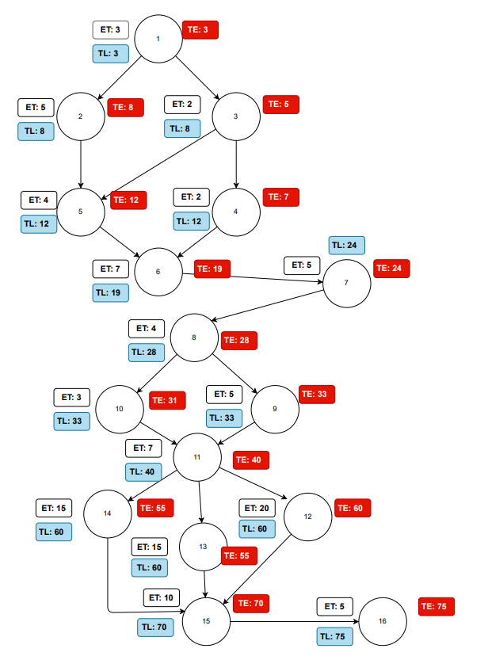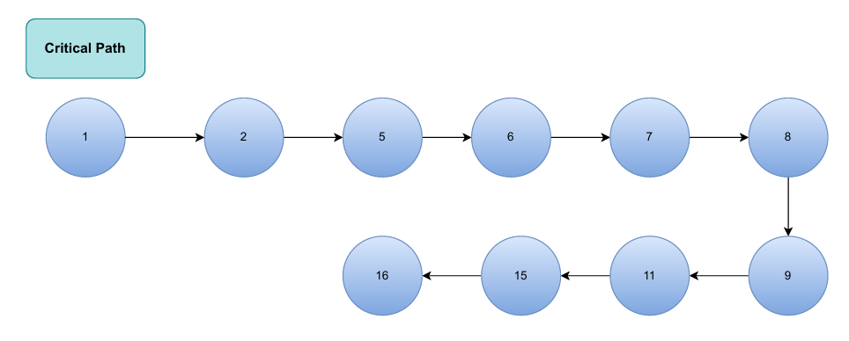

4.3 Gantt Chart Description
The Gantt Chart begins on Week 1 with Activity 1 (Initiation) and spans approximately 75 working days. The first three weeks cover the planning and analysis phases (Activities 1–8), establishing project governance and requirements. Weeks 4–8 cover the design phase (Activities 9–11), including AI architecture and UI/UX prototyping. Weeks 9–18 show the longest parallel development band where the backend, AI model training, and frontend development tracks (Activities 12, 13, 14) run concurrently. The critical path activities are displayed in red on the chart, while non-critical activities with float are shown in blue. The final phase (Activities 15–16: Testing, Deployment & Training) occupies weeks 15–17, completing the project.
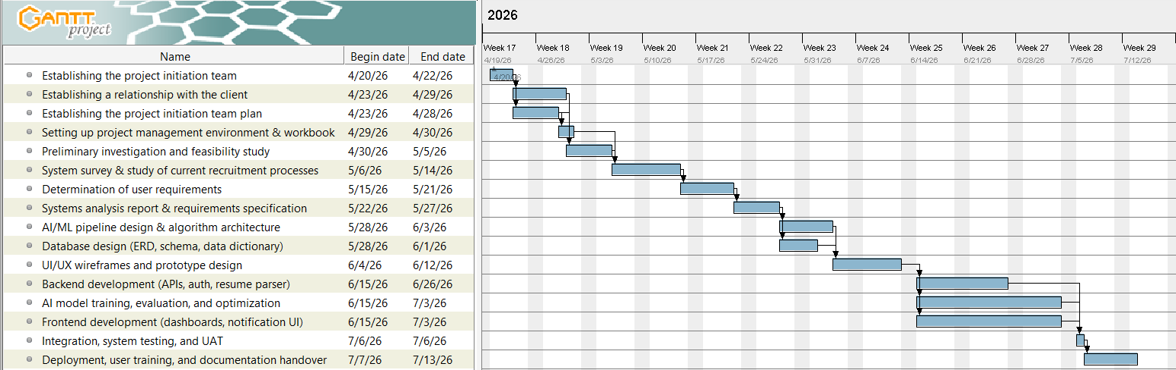

4.4 Economic Feasibility Analysis
Parameter | Value
Benefit per year | $200,000
Discount rate | 15%
Recurring cost per year | $95,000
One-time (development) cost | $155,000
Net economic benefit per year | $200,000
Net recurring cost per year | $95,000

10-Year Economic Feasibility Table
Year | Net Econ. Benefit | Discount Rate (15%) | PV of Benefits | NPV All Benefits | One-Time Cost | Net Econ. Cost | Discount Rate | PV of Cost | NPV All Cost
0 | $0 | 1.0000 | $0 | $0 | $155,000 | $0 | 1.0000 | $0 | $155,000
1 | $200,000 | 0.8695 | $173,900 | $173,900 | — | $95,000 | 0.8695 | $82,602.5 | $237,603
2 | $200,000 | 0.7561 | $151,220 | $325,120 | — | $95,000 | 0.7561 | $71,829.5 | $309,432
3 | $200,000 | 0.6575 | $131,500 | $456,620 | — | $95,000 | 0.6575 | $62,462.5 | $371,895
4 | $200,000 | 0.5717 | $114,340 | $570,960 | — | $95,000 | 0.5717 | $54,311.5 | $426,206
5 | $200,000 | 0.4971 | $99,420 | $670,380 | — | $95,000 | 0.4971 | $47,224.5 | $473,431
6 | $200,000 | 0.4323 | $86,460 | $756,840 | — | $95,000 | 0.4323 | $41,068.5 | $514,499
7 | $200,000 | 0.3759 | $75,180 | $832,020 | — | $95,000 | 0.3759 | $35,710.5 | $550,210
8 | $200,000 | 0.3269 | $65,380 | $897,400 | — | $95,000 | 0.3269 | $31,055.5 | $581,265
9 | $200,000 | 0.2842 | $56,840 | $954,240 | — | $95,000 | 0.2842 | $26,999 | $608,264
10 | $200,000 | 0.2471 | $49,420 | $1,003,660 | — | $95,000 | 0.2471 | $23,474.5 | $631,739

Metric | Value
Overall NPV (Benefits – Costs) | $371,921
Overall ROI | 0.58873 ≈ 58.87%

Break-Even Analysis
Formula: Break-Even Point = Year N + (|Last Negative NPV| / Yearly PV Cash Flow in Year N+1)
Break-Even Point occurs between Year 1 and Year 2
Break-Even Point = (63,702 / 79,391) = 0.802
Break-Even Point occurs at Year 1.802

Year | 0 | 1 | 2 | 3 | 4 | 5 | 6 | 7 | 8 | 9 | 10
Yearly PV Cash Flow | $-155,000 | $91,298 | $79,391 | $69,038 | $60,029 | $52,196 | $45,392 | $39,470 | $34,325 | $29,841 | $25,946
Overall NPV Cash Flow | $-155,000 | $-63,702 | $15,689 | $84,727 | $144,756 | $196,952 | $242,344 | $281,814 | $316,139 | $345,980 | $371,926

Cumulative NPV Benefits vs. Costs by Year
Year | NPV Benefits | NPV Cost
0 | $0 | $155,000
1 | $173,900 | $237,603
2 | $325,120 | $309,432
3 | $456,620 | $371,895
4 | $570,960 | $426,206
5 | $670,380 | $473,431
6 | $756,840 | $514,499
7 | $832,020 | $550,210
8 | $897,400 | $581,265
9 | $954,240 | $608,264
10 | $1,003,660 | $631,739
Break-Even
Point

